Assignment 1 Tasks

# Understanding the Problem

FORMULA.

(Bacteria)( (m x 60 + s)2 900)

After 5 minutes

= 6.30 bacteria

After 20 minutes and 30 seconds

= 12.89 bacteria

After 1 minute

= 5.24 bacteria

# Umlet

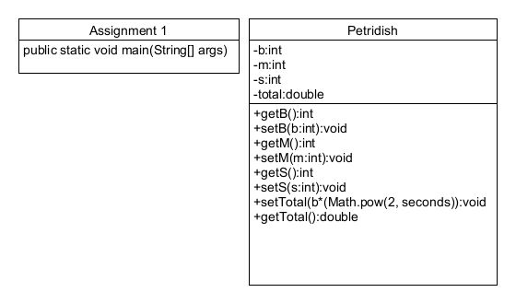

Flowchart

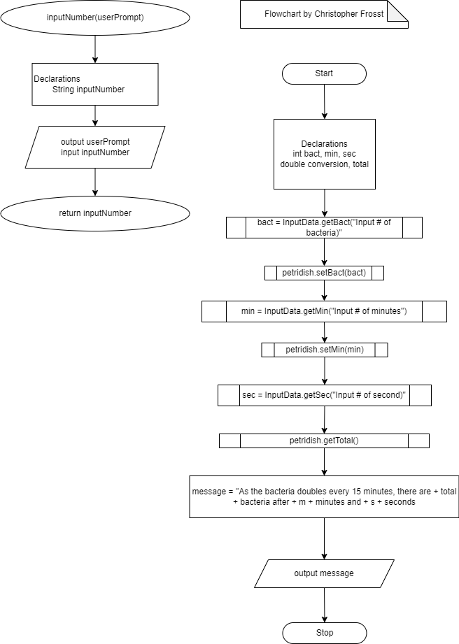

# Pseudocode

Int inputData

Declarations

String inputString

Output userPrompt

Input inputData

Return inputData

Start

Declarations

int bact,min,sec

double total, conversion

bact = inputData.getBact

(“input # of bacteria”)

Petridish.setBact(bact)

min = inputData.getMin

(“Input # of minutes”)

Petridish.setMin(min)

Sec = inputData.getsec

(“Input # of seconds”)

Petridish.setSec(sec)

Output “with a doubling time of 15 minutes, there is + getTotal + “ bacteria”

stop

# Before Test Table

|  |  |
| --- | --- |
| Input | Expected Output |
| 5  5  0 | Input # of bacteria:  Input # of minutes:  Input # of seconds:  “As the bacteria doubles every 15 minutes, there are 1.13 bacteria after 5 minutes and 0 seconds” |
| 7.2  25  23 | Input # of bacteria:  Input # of minutes:  Input # of seconds:  “As the bacteria doubles every 15 minutes, there are 23.27 bacteria after 25 minutes and 23 seconds” |
| 9  19  81 | Input # of bacteria:  Input # of minutes:  Input # of seconds:  “As the bacteria doubles every 15 minutes, there are 23.05 bacteria after 19 minutes and 81 seconds” |
| -4  17  15 | Input # of bacteria:  Input # of minutes:  Input # of seconds:  “As the bacteria doubles every 15 minutes, there are -8.88 bacteria after 17 minutes and 15 seconds” |
| 5  -18  12 | Input # of bacteria:  Input # of minutes:  Input # of seconds:  “As the bacteria doubles every 15 minutes, there are 2.20 bacteria after -18 minutes and 12 seconds” |

# After Test Table

|  |  |  |  |
| --- | --- | --- | --- |
| Input | Expected Output | Actual Output | Description |
| 5  5  0 | Input # of bacteria:  Input # of minutes:  Input # of seconds:  “As the bacteria doubles every 15 minutes, there are 6.30 bacteria after 5 minutes and 0 seconds” | Input # of bacteria:  Input # of minutes:  Input # of seconds:  “As the bacteria doubles every 15 minutes, there are 6.30 bacteria after 5 minutes and 0 seconds” | Input the bacteria, minutes and seconds as integers.  Output 1.13 after formula  b((2^(mX60+s))/900) |
| 7.2  25  23 | Input # of bacteria:  Input # of minutes:  Input # of seconds:  “As the bacteria doubles every 15 minutes, there are 23.27 bacteria after 25 minutes and 23 seconds” | Input # of bacteria:  error | Entering a unit as a decimal value causes an error since the variable is an int. |
| 9  19  81 | Input # of bacteria:  Input # of minutes:  Input # of seconds:  “As the bacteria doubles every 15 minutes, there are 23.05 bacteria after 19 minutes and 81 seconds” | Input # of bacteria:  Input # of minutes:  Input # of seconds:  “As the bacteria doubles every 15 minutes, there are 23.05 bacteria after 19 minutes and 81 seconds” | Inputting seconds more than 60 still does the math correctly |
| -4  17  15 | Input # of bacteria:  Input # of minutes:  Input # of seconds:  “As the bacteria doubles every 15 minutes, there are -8.88 bacteria after 17 minutes and 15 seconds” | Input # of bacteria:  Input # of minutes:  Input # of seconds:  “As the bacteria doubles every 15 minutes, there are -8.88 bacteria after 17 minutes and 15 seconds” | Input a negative bacterium and the answer will be negative |
| 5  -18  12 | Input # of bacteria:  Input # of minutes:  Input # of seconds:  “As the bacteria doubles every 15 minutes, there are 2.20 bacteria after -18 minutes and 12 seconds” | Input # of bacteria:  Input # of minutes:  Input # of seconds:  “As the bacteria doubles every 15 minutes, there are 2.20 bacteria after -18 minutes and 12 seconds” | Input negative minutes and the formula will provide a lower number than the bacteria |

# Java Codes

# 

# References

### CITATION.

[1] “Exponential growth formula - formulas, examples,” Cuemath, https://www.cuemath.com/exponential-growth-formula/ (accessed Feb. 8, 2024).